Programming Fundamentals and Unit Testing
Regular Exam – 2 March 2025
Submit your zip file here: https://judge.softuni.org/Contests/5375/Programming-Fundamentals-and-Unit-Testing-Regular-Exam-2-March-2025

3. Unit Test Method: Even Numbers in Range
Test a given method which takes in two integers and returns all even numbers in the range.

Examples
Input | Output
10 1 | Start number should not be greater than end number.
23 23 | (empty string)
21 23 | 22
1 5 | 2 4
0 0 | 0
The method is found in the EvenNumbersFinder.cs file:
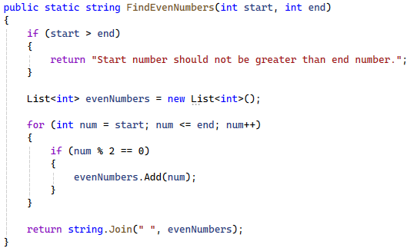
You are given a test file EvenNumbersFinderTests.cs containing 5 empty tests. Implement all the unit tests:
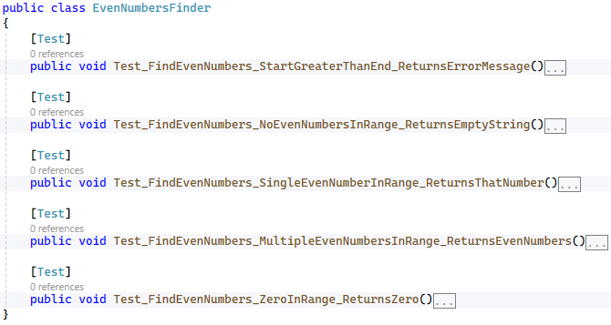
When you are ready make sure your tests run:
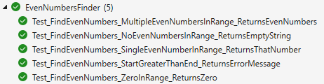
IMPORTANT: DO NOT REMOVE OR CHANGE ANY NAMESPACES AND USINGS.

